**Use system variables in adobe forms**

1. Go to Tcode SFP .Create an interface and then create a form(For details ,please refer the previous demos)

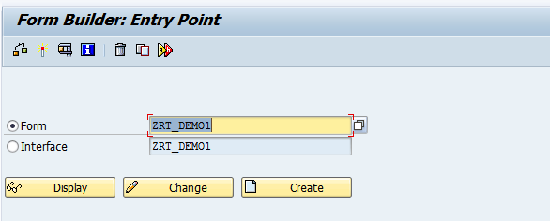

1. Open the Form. Expand the System fields .Drag and drop DATE, TIME, USERNAME to the context area. 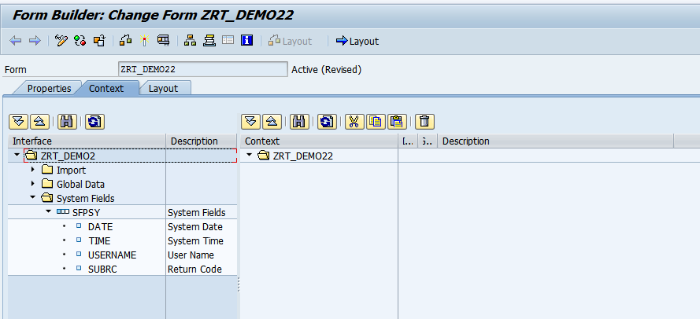
2. System field appears in the Context area. Save and Click on Layout.

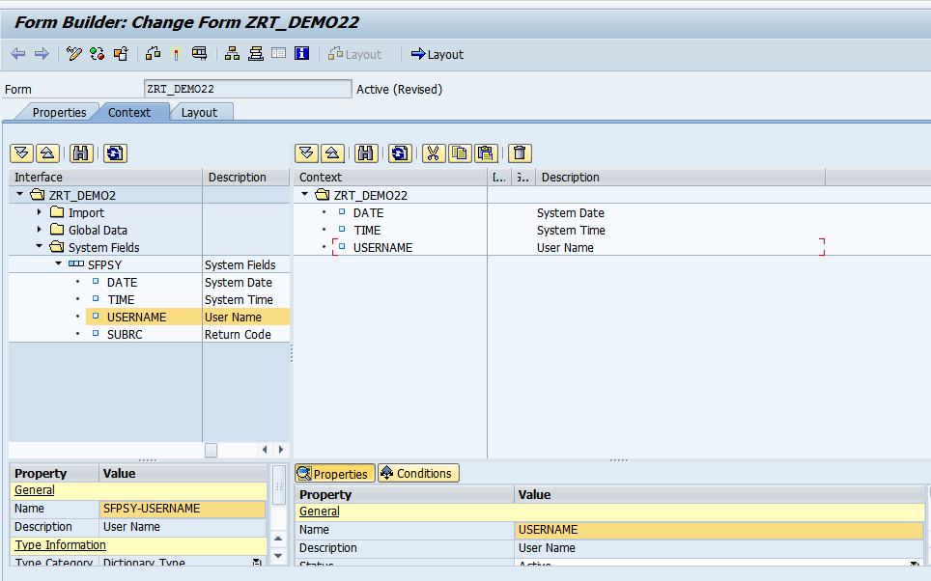

1. Go to Palettes-Object Library. Drag and drop 3 text fields to Design View. Name the fields as DATE, USER, and NAME.

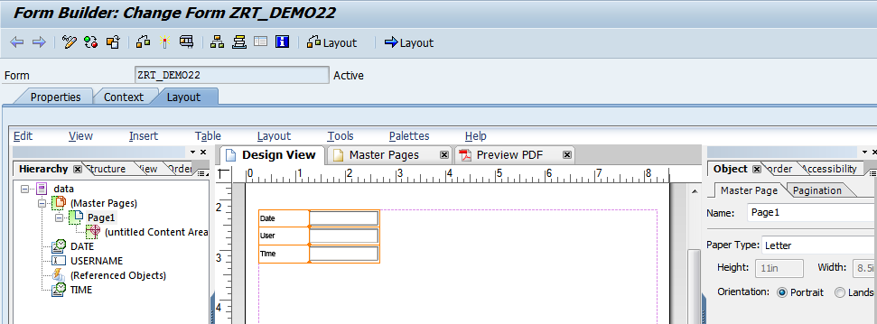

1. Go to Palettes-Object. In the object window, bind the Date field to the system Date as shown

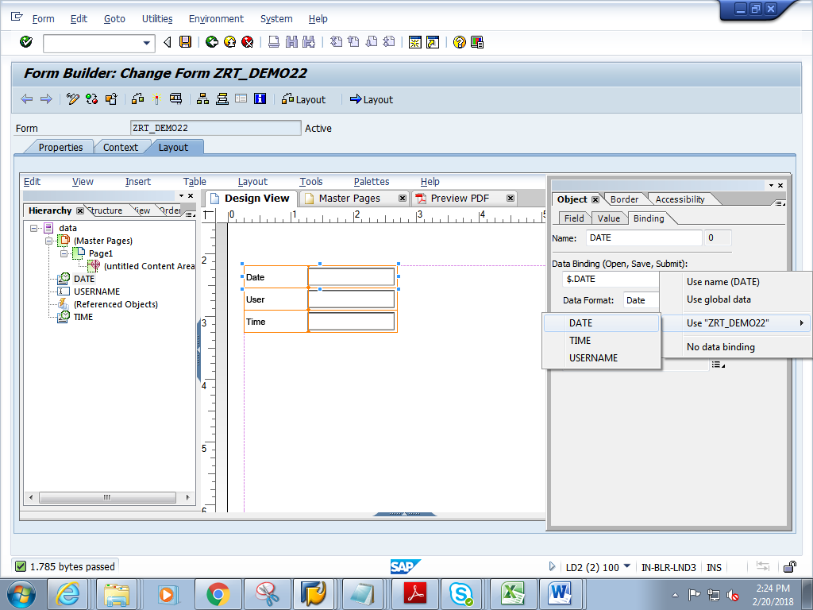

1. Similarly bind the text fields USER to USERNAME and Time to TIME as shown below.

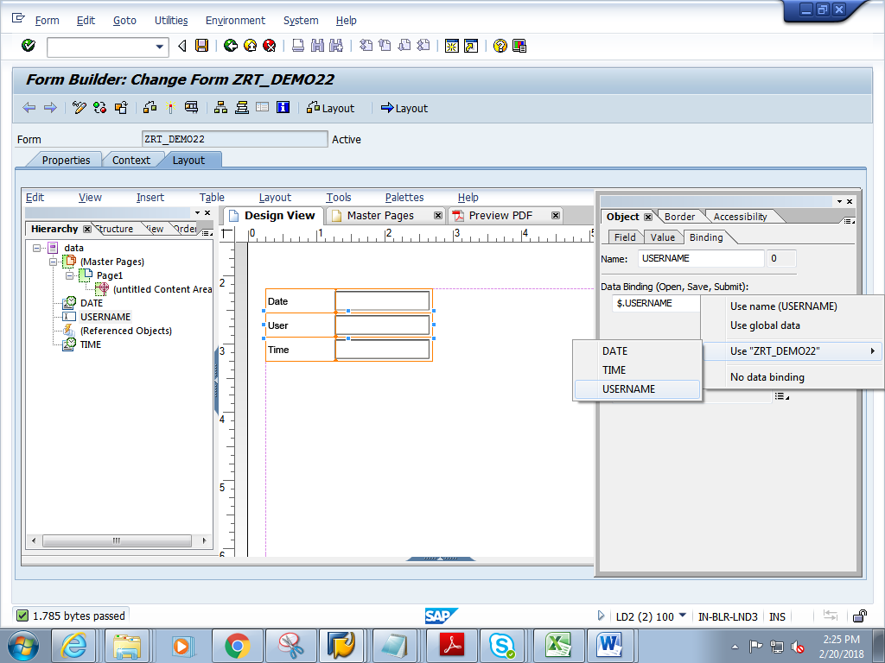

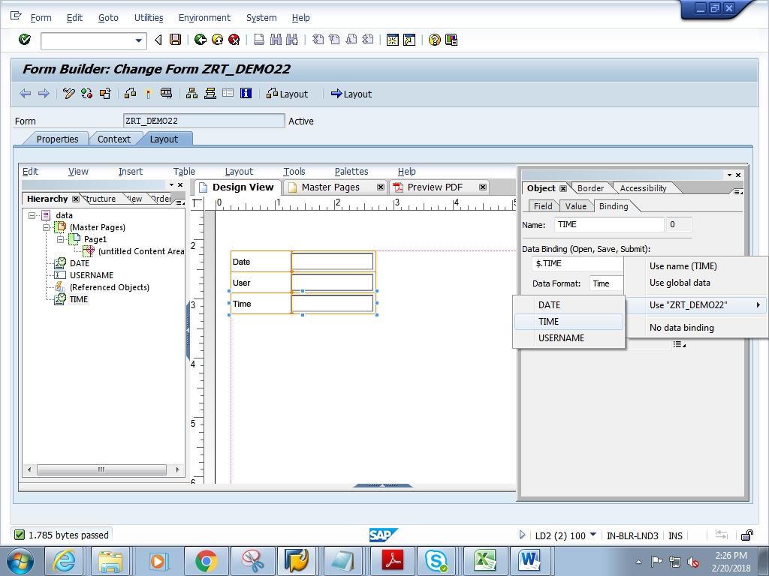

1. Save and close the Layout.
2. Click on context. Save and activate the form
3. Execute the form .Execute the function module

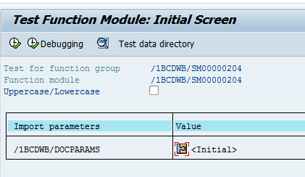

1. Click on Print preview

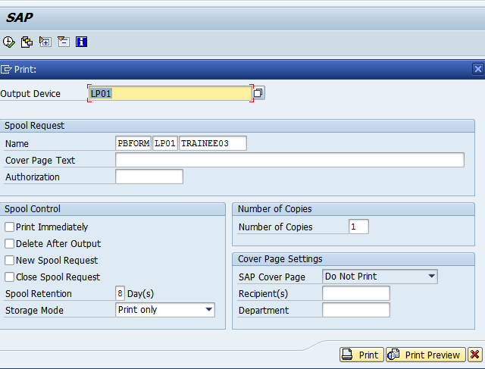

1. Expected output is as follows.

